**LED Controller with Different Mods**

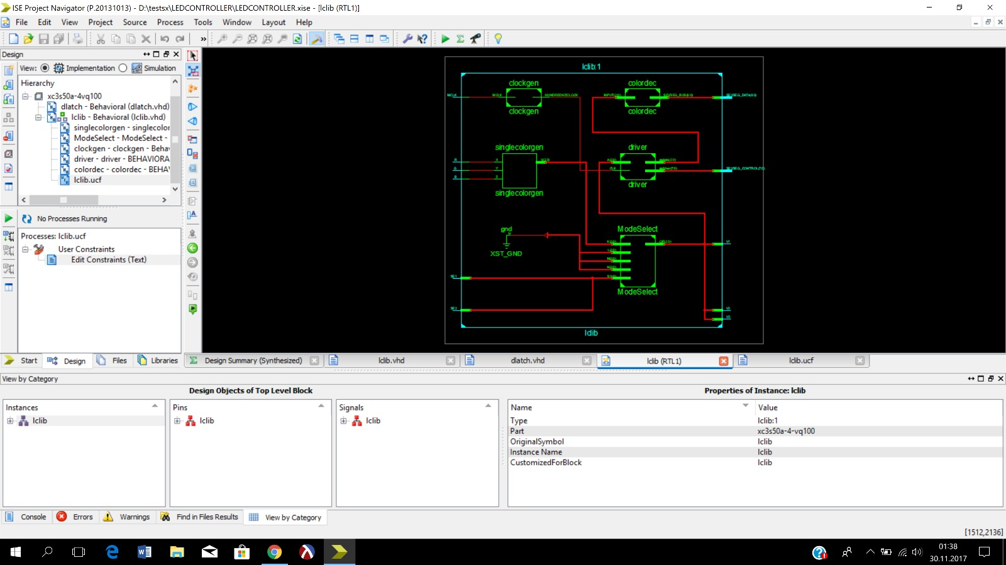The aim of this project is to control a LED with our FPGA board using VHDL code. This project requires six inputs and produces five outputs. The inputs are called Red, Blue, Green, Selector1, Selector2 and MCLK. The outputs are SEVSEG_DATA, SEVSEG_CONTROL, Voltage1, Voltage2 and Voltage3. The Red, Blue, Green are the inputs of the decoder. Those 3 inputs are passing through the functional block called singlecolorgen to get 7 different color. The output of the 3 to 8 Decoder is called I. I is the input of the multiplexer which is named ModeSelector. This multiplexer is used to decide which mode that the user wants to use. The inputs of the multiplexer are the SingleColorGenerator, Fade, Pulse, FasterFade or Microphone; and the selector inputs are Selector1 and Selector2. The usage of the selector inputs is to decide which mode the user wants. This output is 3 bit which are Red, Green and Blue. The 3-digit value is the source to light up the LED by the output pins of the FPGA board. That value is also used to be an input of the SevenSegmentDriver. The usage of the seven segment is that the color of the LED will be shown in the seven-segment display at the same time. So that the SevenSegmentDriver has another input which is the output of the ClockGenerator. The general input MCLK is the input of the ClockGenerator. The SevenSegmentDriver has two outputs which are SEVSEG_CONTROL and a signal which is the input of the ColorDecoder. The ColorDecoder is used to decide which input represents which output in letters to show at seven segment displays. In SingleColorMode the user defines the color that desired via the switches on FPGA board which are the far three left switches. Those 3 switches represent Red, Green, Blue. The far right two switches are used to select modes. Those 3 switches represent the selectors. According to switches the LED lights up the desired color and displays color on the seven-segment display. In Fade mode the colors are used to change in a routine which is repeated. The lights will be continuously on. This routine will be designed in a way so that it will repeat until the mode changes. In pulse mode the LED will blink in routine colors. The LED will blink with color and it will be continuous so that it will not stop until the mode changes. The last mode which is microphone mode requires an external microphone to attach the FPGA Board. There will be a threshold value, if the input of the microphone reaches the threshold value the LED will change its color. In a nutshell our project is to design a controller for a LED with different modes. There is the schematic view of our project.

The other three modes rather than singlecolorgen is grounded since we have not finished to write them. Until the checkpoint, we design the blocks of first three modes and write the first mode’s code which singlecolorgen and decided how to write the fade and pulse modes. We decided to have d-flip flop for the pulse mode where our R,G,B inputs set and reset by the clock input. That way, we think that we could have managed to have a color and none-color respectively. However, we could not decide how to write the fade mode. We think that having a 3-bit adder that adds RGB to 001 everytime will help us but we are not sure at all if we can have proper endless loop for it.